Experiment No-01
Study of CMOS Inverter Schematics in Cadence Virtuoso Software
1.1 Objectives
The main objectives of this experiment are summarized as:
- To understand the concept and operation of a CMOS inverter as the fundamental building block of digital logic circuits.
- To become familiar with the Cadence Virtuoso schematic editor and the standard IC design flow used to create standard cells.
- To design the transistor-level schematic of a CMOS inverter using NMOS and PMOS devices from the gpdk090 technology library, and to generate its schematic symbol.
- To construct a test bench for the inverter and verify its functionality through DC and transient simulation using Spectre in the Analog Design Environment (ADE L).
- To obtain and analyze the voltage transfer characteristic (VTC) and the transient input/output waveforms of the designed inverter.
Keywords- CMOS inverter, NMOS, PMOS, Cadence Virtuoso, schematic editor, Spectre, voltage transfer characteristic (VTC), truth table, standard cell.
1.2 Theory
An inverter, also called a NOT gate, is the simplest logic circuit in digital electronics. It has a single input and produces an output that is the logical complement of that input, expressed by the Boolean expression Y = A′. Whenever the input is LOW (logic 0), the output is HIGH (logic 1), and whenever the input is HIGH (logic 1), the output is LOW (logic 0). The truth table of an ideal inverter is shown in Table-1.1.
A (Input) | Y = A′ (Output)
0 | 1
1 | 0
Table-1.1. Truth table of an ideal logic inverter (NOT gate).
1.2.1 The CMOS Inverter
A Complementary Metal-Oxide-Semiconductor (CMOS) inverter implements the NOT function using a complementary pair of transistors: a PMOS transistor connected between the output node and the supply voltage VDD (the pull-up network), and an NMOS transistor connected between the output node and ground, VSS (the pull-down network). The gates of the two transistors are tied together to form the single input terminal, and their drains are tied together to form the output terminal.
When the input is LOW (logic 0), the NMOS transistor is OFF and the PMOS transistor is ON, so the output node is pulled up to VDD, producing a HIGH output. When the input is HIGH (logic 1), the NMOS transistor turns ON and the PMOS transistor turns OFF, pulling the output down to ground and producing a LOW output. Because exactly one of the two transistors is ON in either steady state and the other is OFF, there is no direct conduction path from VDD to ground, and the static power dissipation of a CMOS gate is ideally zero; power is dissipated mainly during switching (dynamic power) and due to leakage currents in real devices.
1.2.2 Voltage Transfer Characteristic (VTC) and Transistor Sizing
The Voltage Transfer Characteristic (VTC) of an inverter is a plot of the output voltage (Vout) as a function of the input voltage (Vin), obtained from a DC sweep of the input. The point on this curve where Vin equals Vout is called the switching threshold voltage, VM. For a symmetric and noise-robust design, VM is usually targeted close to VDD/2, and the transition from HIGH to LOW should be as sharp as possible.
Because the mobility of holes in a PMOS transistor is lower than the mobility of electrons in an NMOS transistor, a PMOS device must be made wider than an NMOS device of the same length to provide comparable pull-up and pull-down drive strength. A commonly used sizing rule, also followed in this experiment, is to make the PMOS width approximately two to three times the NMOS width (a ratio of 3:1 is used here, with WP = 720 nm and WN = 240 nm for the same channel length of 100 nm). Proper sizing balances the rise time and fall time of the output and keeps the switching threshold close to the midpoint of the supply range.
1.2.3 Cadence Virtuoso Design Flow
In this experiment, the CMOS inverter is designed and verified using the Cadence Virtuoso IC design environment. The overall flow consists of creating a design library attached to a process technology library (gpdk090), drawing the transistor-level schematic in the Schematic XL editor by placing and sizing NMOS and PMOS instances and wiring them together, generating a schematic symbol for the inverter cell, and finally building a separate test bench schematic in which the inverter symbol is instantiated along with input and supply sources. The test bench is then simulated using the Spectre simulator inside the Analog Design Environment (ADE L) to verify the inverter’s transient and DC behaviour.
1.3 Hardware/Software Used for the Experiment
1. Cadence Virtuoso Schematic Editor (Schematic XL)
2. Virtuoso Analog Design Environment (ADE L)
3. Spectre circuit simulator
4. gpdk090 generic process design kit (technology library)
5. NMOS and PMOS transistors (gpdk090_nmos1v, gpdk090_pmos1v)
6. Pulse voltage source (vpulse), DC voltage source (vdc) and ground (gnd) from analogLib
7. Linux workstation running the Cadence design environment
1.4 Experimental and Simulation Analysis
A new design library (myDesignLib) was created and attached to the gpdk090 technology library, and a schematic cellview named inverter was created within it. NMOS and PMOS instances were placed in the schematic, sized as described in Section 1.2.2, and wired together with input, output and supply pins. A schematic symbol was then generated for the inverter cell. A separate test schematic (inverter_test) was built in which the inverter symbol was instantiated with a pulse source at its input and a DC supply and ground connected to its power pins, and the design was simulated in ADE L using the Spectre simulator. Each of these steps is illustrated below.
1.4.1 Transistor Sizing and Parameter Selection
The width and length of each transistor were set in the Add Instance window at the time of placement. The NMOS transistor was sized with a total width of 240 nm and a channel length of 100 nm, while the PMOS transistor was sized with a total width of 720 nm and the same channel length of 100 nm, giving the 3:1 PMOS-to-NMOS width ratio discussed in Section 1.2.2. The parameter selection window used for setting the NMOS device dimensions is shown in Figure-1.1.
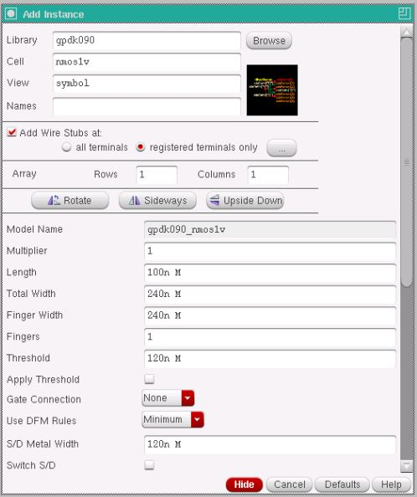
Figure-1.1. Add Instance window showing the width and length parameters set for the NMOS transistor (Total Width = 240n, Length = 100n).
Device | Width (W) | Length (L)
NMOS (gpdk090_nmos1v) | 240 nm | 100 nm
PMOS (gpdk090_pmos1v) | 720 nm | 100 nm
Table-1.2. Device parameters used for the NMOS and PMOS transistors in the inverter schematic.
1.4.2 Transistor-Level Schematic of the CMOS Inverter
The PMOS source was connected to the Vdd pin and the NMOS source was connected to the Vss pin, while the drains of both transistors were tied together to form the output net (out); the gates of both transistors were tied together to form the input net (in). The complete transistor-level schematic of the CMOS inverter, with all pins and wires labelled, is shown in Figure-1.2.
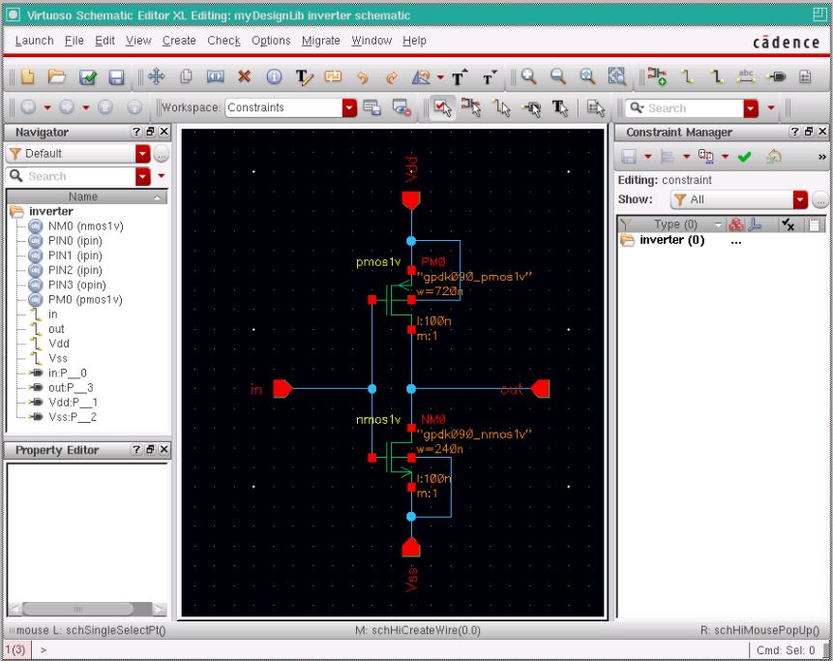
Figure-1.2. Complete transistor-level schematic of the CMOS inverter, showing the PMOS pull-up network, the NMOS pull-down network, and the in, out, Vdd and Vss pins.
1.4.3 Schematic Symbol Generation
After the schematic was checked and saved without errors, a schematic symbol was generated from the cellview using Create → Cellview → From Cellview, with in and out placed as the left and right pins respectively, and Vdd and Vss placed as the top and bottom pins. The default rectangular shape generated by Virtuoso was replaced with a triangle and an output bubble, the conventional symbol used for an inverter, as shown in Figure-1.3.
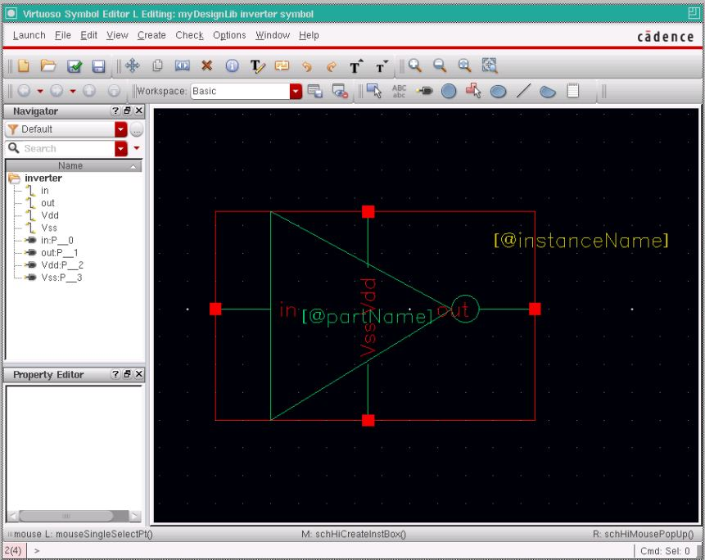
Figure-1.3. Generated schematic symbol of the CMOS inverter, redrawn as a triangle with an output bubble, with a red selection box automatically added around it.
1.4.4 Test Bench Construction and Source Addition
A separate schematic, inverter_test, was created to verify the inverter. The generated inverter symbol was instantiated, and a pulse voltage source (vpulse) from analogLib was connected to its input with voltage1 = 0 V, voltage2 = 1.8 V, period = 20 ns and pulse width = 10 ns. A DC voltage source (vdc) set to 1.8 V and a ground (gnd) were connected to the Vdd and Vss pins respectively, and the input and output nets were named Vin and Vout using Create → Wire Name. The completed test bench, with all sources added, is shown in Figure-1.4.
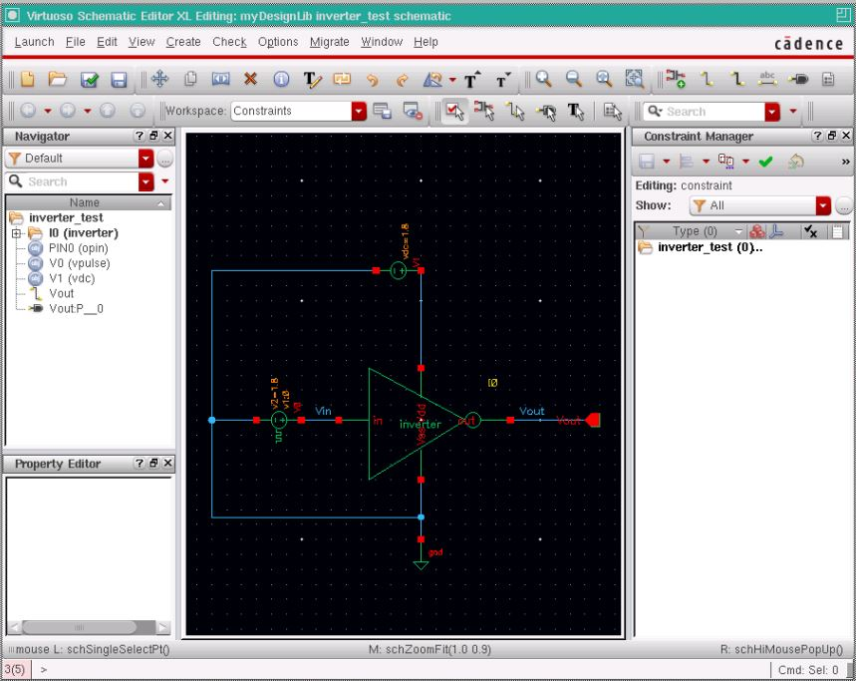
Figure-1.4. Test bench schematic (inverter_test) with the pulse input source, the DC supply, ground, and the inverter symbol, with the Vin and Vout nets labelled.
1.4.5 Simulation Setup
The test bench was simulated in ADE L using the Spectre simulator, with the gpdk090 Spectre model library added under Setup → Model Libraries. A transient analysis was configured with a stop time of 200 ns, and a DC analysis was configured to sweep the DC voltage of the vpulse source from 0 V to 1.8 V, with the operating point saved. The input net Vin and the output net Vout were selected as the outputs to be plotted, and the simulation was run using Simulation → Netlist and Run.
1.4.6 Simulation Results: Input and Output Waveforms
Figure-1.5 shows the simulated transient response and the DC voltage transfer characteristic (VTC) of the inverter. In the transient response, Vin is a periodic pulse waveform switching between 0 V and 1.8 V with a 20 ns period and a 10 ns pulse width, and Vout is observed to switch in the opposite sense, remaining close to 1.8 V while Vin is LOW and close to 0 V while Vin is HIGH, confirming correct inverter operation. In the DC response, Vout decreases monotonically as Vin is swept from 0 V to 1.8 V, and the switching threshold voltage VM, the point where the rising Vin line intersects the falling Vout curve, is observed close to the midpoint of the supply range, consistent with the PMOS-to-NMOS sizing ratio used in the design.
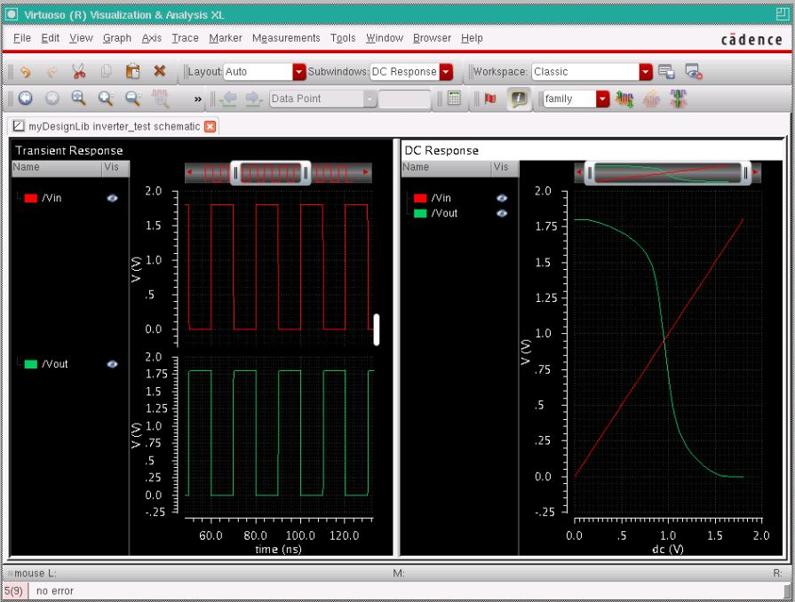
Figure-1.5. Simulation results: (left) transient response showing the pulse input Vin and the inverted output Vout, and (right) the DC voltage transfer characteristic (VTC) of the CMOS inverter.
1.5 Discussion
The simulated behaviour of the designed circuit was found to be in agreement with the theoretical operation of a CMOS inverter described in Section 1.2. The transient simulation confirmed that the output waveform is the logical complement of the input pulse waveform in every cycle, matching the expected truth table (Table-1.1). The DC simulation showed a well-defined voltage transfer characteristic with a sharp transition region, and the switching threshold voltage obtained was close to the expected value near VDD/2, verifying that sizing the PMOS transistor three times wider than the NMOS transistor successfully compensated for the lower mobility of holes compared to electrons. Because the pull-up and pull-down networks are never both ON at the same time, the circuit is also expected to dissipate negligible static power, consistent with the fundamental advantage of CMOS logic. Minor deviations of the switching threshold from the ideal midpoint value can be attributed to the specific device models and parasitic effects included in the gpdk090 technology library.
1.6 Conclusion
In this experiment, a CMOS inverter was successfully designed at the transistor level in Cadence Virtuoso using NMOS and PMOS devices from the gpdk090 technology library, and its schematic symbol was generated. A test bench was constructed with a pulse input source and DC supply, and the circuit was verified through transient and DC simulation using Spectre in ADE L. The observed input-output waveforms and the voltage transfer characteristic confirmed that the circuit correctly performs the logical NOT operation, and the extracted switching threshold voltage validated the transistor sizing strategy used in the design. This experiment provided practical, hands-on experience with the standard-cell schematic design flow that forms the basis for more complex digital and mixed-signal IC design in subsequent experiments.

